5th October 2023

Dear parent/carer,

Our vision at Newsome Academy is to support our students in being exceptional every day and having the very highest of aspirations. Assessments are a key feature of a pupil’s educational journey and are ultimately the final challenge that students must conquer in year 11.

To support our students to develop their independent study, revision and time management skills we will be facilitating year 11 mock examinations beginning on November 6th. These assessments will take place in the sports hall for the majority of subjects and students and will offer a valuable experience of the routines and procedures involved in the real GCSE examinations.

These are the first of two mock assessments students will sit before the real, external examinations that begin in May. Therefore, this is an excellent opportunity for students to demonstrate their ability and practice revision and exam techniques in the same setting as the GCSE exams. The importance of the assessments cannot be understated, as their proximity to the real GCSE papers means students results here will impact the interventions they receive and the content and skills teachers deliver in lessons.

The assessments are designed not only to allow students to experience exam preparation but also to ensure any misconceptions and gaps in knowledge are identified and students receive the support and intervention they need in order to be successful in year 11.

We ask that you assist us where possible by using the timetables on our academy website to support your child in managing their revision schedule and preparing for any assessments they will sit as best they can. The timetables can be found on the school website here via the Students – Assessment tab, with other resources such as useful websites and revision lists where appropriate.

Thank you for your ongoing support.

Yours faithfully,

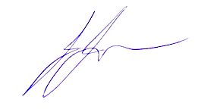

Joshua Jesson
Assistant Headteacher

