Language Paper 1
Youtube videos to help
AQA English Language Paper 1 Question 1 (2024 onwards) - YouTube

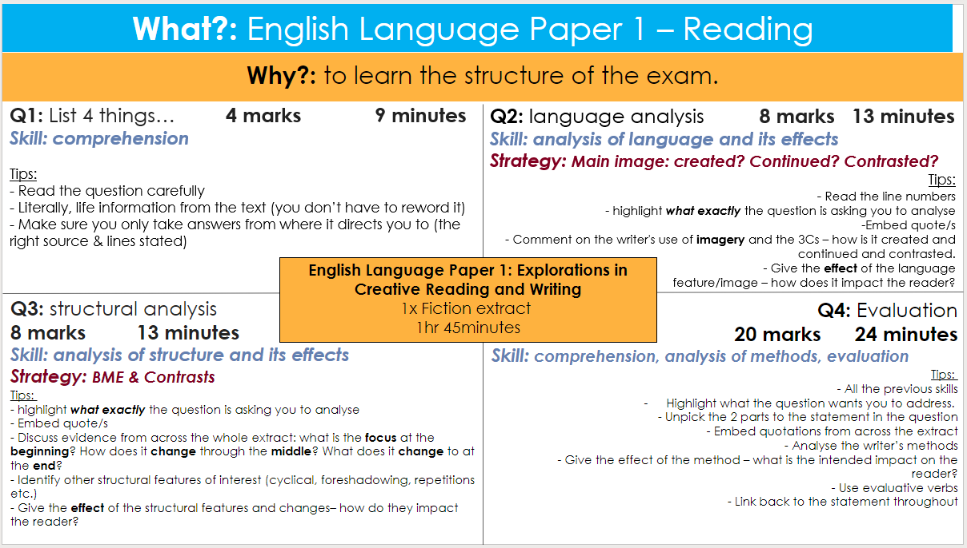

An Inspector Calls
'An Inspector Calls' by J.B Priestley - YouTube
An Inspector Calls - GCSE English Literature Revision - AQA - BBC Bitesize
Love and relationships poetry
AQA 'Love and Relationships' Poetry - YouTube
AQA GCSE English Section B: Love and Relationships Poetry Anthology - PMT (physicsandmathstutor.com)
Poems - GCSE English Literature Revision - AQA - BBC Bitesize

Unseen Poetry
Mr Bruff Unseen Poetry - YouTube
AQA GCSE English Section C: Unseen Poetry - PMT (physicsandmathstutor.com)
Responding to poems - Comparing unseen poems – WJEC - GCSE English Literature Revision - WJEC - BBC Bitesize

